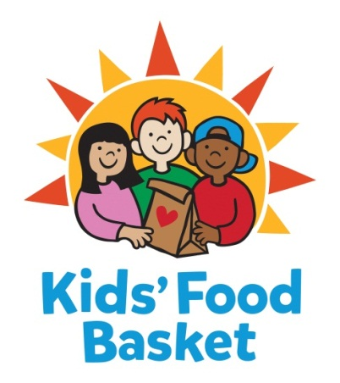

INTERNSHIP DESCRIPTION

Job Title: Accounting Intern
Reports to: Accounting Manager
Date: March 17, 2020

Kids’ Food Basket believes all children have a right to equitable, consistent access to the nutrition they need to grow. We got our start 17 years ago by serving 125 kids each school day through our Sack Supper program, and now we serve nearly 8,800 kids each school/summer program day throughout Kent, Muskegon and Ottawa + Allegan counties. Nourishing healthier generations of children is at the core of Kids’ Food Basket’s mission and is what we strive for daily through our four Commitments:

- We Nourish our future by providing ready to eat healthy food on a daily basis to children in need,
- We Grow by increasing healthy food access for our communities through the growth and distribution of sustainably grown vegetables and fruit,
- Our community Learns through the use of our facilities and farm as classrooms to foster learning and empowerment across economic barriers,
- We Engage our diverse community to work for Good Food for all.

If you are passionate about nourishing children to reach their dreams, then consider joining our team!
Main Job Responsibilities
- Assist with the income process: potential tasks include opening of mail, log incoming checks, prepare deposit for data entry
- Assist with entering income information into donor database software
- Assist with monthly and ad hoc financial reporting
- Assist with annual inventory process
- Assist with annual budget preparation and data entry
- Assist with annual audit workpaper preparation
- Provide support to our nonprofit organization by working with a variety of departments on a variety of projects

General

- Additional hours due to special events
- Effectively interact with a diverse population of volunteers and donors
- Support in the overall operations of the organization and be a dependable and versatile member of the Kids’ Food Basket team
Qualifications

Educations and/or Experience:
Pursuit of higher education degree in accounting or business administration at an accredited university.

- Passion for and commitment to attacking childhood hunger and nourishing kids to be their best in school and in life
- Initiative, independence and tenacity; able to identify and prioritize actions towards a goal
- Effective communication skills – verbal, written, presentation– with audiences diverse in age, race, etc.
- Willingness to collectively and personally work to close persistent opportunity gaps based on race, class, culture and power
- A sense of optimism and an assets-based way of viewing people and situations
- An orientation towards problem-solving and value creation – experience identifying root causes and developing results-oriented solutions
- Servant Leadership – strong commitment to team with colleagues and partners by sharing responsibility for successes and growth opportunities

Physical Activities

- Fingering: Picking, pinching, typing or otherwise working, primarily with fingers rather than with the whole hand as in handling.
- Talking: Expressing or exchanging ideas by means of the spoken word. Those activities in which you must convey detailed or important spoken instructions to other workers accurately, loudly or quickly.
- Light work: Exerting up to 20 pounds of force occasionally, and/or up to 10 pounds of force frequently, and/or negligible amount of force constantly to move objects.
- Visual Acuity: The worker is required to have close visual acuity to perform an activity such as: preparing and analyzing data and figures; transcribing; viewing a computer terminal; extensive reading.
- The workers is not substantially exposed to adverse environmental conditions
- Reasonable accommodations may be made to enable individuals to perform the essential functions.

Schedule: Work 12 to 15 hours per week; usual schedule will be during normal business hours from 8 am to 5 pm. Potential for early mornings, evenings or weekends opportunities may occur.

Compensation: Tier one internship for 150 hours school credit or stipend

Benefits: No benefits.

To be considered for the position, applicants must send cover letter and resume via email as soon as possible. Applications will be reviewed as they are received.
(NO CALLS PLEASE)

Send cover letter and resume to:

Robin DeYoung
hiring@kidsfoodbasket.org

Kids’ Food Basket is an equal opportunity employer. Our policy provides equal employment opportunities (EEO) to all employees and applicants for employment without regard to race, creed, ethnicity, gender/gender identity, sexual orientation, religious belief, sex, national origin, age, ancestry, qualifying physical or mental disability, height, weight, marital status, veteran status or genetics. In addition to federal law requirements, Kids’ Food Basket complies with applicable state and local laws governing nondiscrimination in employment in every location in which the company has facilities.

