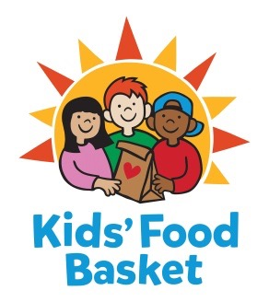

INTERNSHIP DESCRIPTION

TITLE: Marketing & Communications Intern
REPORTS TO: Marketing & Communications Manager
DATE: December 9, 2019

Kids’ Food Basket believes all children have a right to equitable, consistent access to the nutrition they need to grow. We got our start 17 years ago by serving 125 kids each school day through our Sack Supper program, and now we serve nearly 8,800 kids each school/summer program day throughout Kent, Muskegon and Ottawa + Allegan counties. Nourishing healthier generations of children is at the core of Kids’ Food Basket’s mission and is what we strive for daily through our four Commitments:

- We Nourish our future by providing ready to eat healthy food on a daily basis to children in need,
- We Grow by increasing healthy food access for our communities through the growth and distribution of sustainably grown vegetables and fruit,
- Our community Learns through the use of our facilities and farm as classrooms to foster learning and empowerment across economic barriers,
- We Engage our diverse community to work for Good Food for all.

If you are passionate about nourishing children to reach their dreams, then consider joining our team!

Internship Duties:

- Social Media | Social media support on all channels (Facebook, Twitter, Instagram) including but not limited to: scheduling posts, creating social media supporting images/graphics in Canva, commenting/responding to comments, pulling analytic reports each week and making suggestions for areas of improvement.
- Conduct website, digital and collateral audits.
- Event Support | Assist with the planning, logistics and event support at onsite and offsite Kids’ Food Basket community and donor event.
- Assist in creating digital marketing strategy and managing project timelines.
- Additional administrative support, including | Preparing packets and outreach materials for donor meetings and assisting with writing projects as needed.

Skills and Qualifications:

- Bachelor’s degree in progress.
- Excellent written and verbal communication skills.
- Organized, with the ability to work in a fast paced, ever-changing work environment.
- Possesses skills in project and time management.
- Well versed in computer programs (Microsoft Office required).
- Can work independently as well as collaboratively.
- Demonstrate the ability to solve problems, analyze systems and data, and make suggestions for improvement.
- Photography skills highly desired.
- Videography experience highly desired.

Level I | Part-time Internship - for College Credit (Prior approval from intern’s school needed for College Credit).

Schedule: 10 to 15 hours per week

To be considered for this internship, please send a cover letter and a resume to:
hiring@kidsfoodbasket.org
Attn: Alyson Ramirez

NO CALLS PLEASE!

Internships are available each semester – please apply year round

Kids’ Food Basket is an equal opportunity employer. Our policy provides equal employment opportunities (EEO) to all employees and applicants for employment without regard to race, creed, ethnicity, gender/gender identity, sexual orientation, religious belief, sex, national origin, age, ancestry, qualifying disability, height, weight, marital status, veteran status or genetics. In addition to federal law requirements, Kids’ Food Basket complies with applicable state and local laws governing nondiscrimination in employment in every location in which the organization has facilities.

