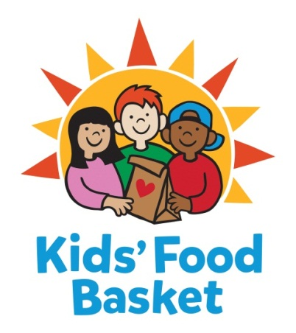

INTERNSHIP DESCRIPTION

Title: Development: Events Intern - Muskegon
Reports to: Muskegon Regional Program Director
Date: November 6th, 2019

Kids’ Food Basket believes all children have a right to equitable, consistent access to the nutrition they need to grow. We got our start 17 years ago by serving 125 kids each school day through our Sack Supper program, and now we serve nearly 8,800 kids each school/summer program day throughout Kent, Muskegon and Ottawa + Allegan counties. Nourishing healthier generations of children is at the core of Kids’ Food Basket’s mission and is what we strive for daily through our four Commitments:

- We Nourish our future by providing ready to eat healthy food on a daily basis to children in need,
- We Grow by increasing healthy food access for our communities through the growth and distribution of sustainably grown vegetables and fruit,
- Our community Learns through the use of our facilities and farm as classrooms to foster learning and empowerment across economic barriers,
- We Engage our diverse community to work for Good Food for all.

If you are passionate about nourishing children to reach their dreams, then consider joining our team!

Internship runs from late January to late May, 2020.

Internship Duties:

- Signature Events | Support signature events during the semester including Chef Prize and other events including but not limited to event logistics, sponsorship, individual ticket sales and auction support, invoicing and donor stewardship
- Connect Events | Assist with annual Connect with Kids’ Food Basket events including coordination of guest RSVP, food and donor packets
- Expansion Campaign Events | Assist with event logistics for our Feeding Our Future expansion campaign events including coordination of guest RSVP, food, donor packets and additional as assigned
- Community Partner Program | Provide support for a robust Community Partner Program, including, but not limited to, securing logos from corporate entities and ensuring recognition levels are correct and donor stewardship
- Community/Outreach Events | Assist Kids’ Food Basket team with activities at Kids’ Food Basket events in the community
- Third Party Fundraisers | Provide coordination and support for third party events including information, scheduling, and Kids’ Food Basket representation at events as needed
- Peer to Peer Fundraising Events | Support Kids’ Food Basket team with support of Peer to Peer Fundraising Events including assistance of prospecting events and donors, assist with stewardship and promotion of Peer to Peer Fundraising platform
- Additional administrative support | Support Kids’ Food Basket team with administrative duties including but not limited to answering phones, meeting prep and donor stewardship, donor and volunteer data entry
- Misc. duties as assigned

General Job Functions

- Participate in and assist with, daily tasks of Kids’ Food Basket.
- Physical requirements include a typical office environment, with periods of sitting at a computer screen and being able to lift up to 25 pounds.
- Flexible scheduling, evening and weekend hours will be necessary. We are seeking an individual that would have ability to attend events during day and evening and weekends as needed. This position would require at least 10- 15 hours per week.

Skills and Qualifications

- Bachelor degree in progress.
- Excellent written and verbal communication skills.
- Organized with the ability to work in a fast paced, ever changing work environment.
- Possesses skills in project and time management.
- Well versed in computer programs (Microsoft Office required).
- Can work independently as well as collaboratively.
- Demonstrate the ability to solve problems, analyze systems and data, and make suggestions for improvement.

Level I | Part-time Internship for Stipend ($599 after 150 hours completed) or School Credit (Student is responsible for arranging approval from their school).

Kids’ Food Basket is an equal opportunity employer. Our policy provides equal employment opportunities (EEO) to all employees and applicants for employment without regard to race, creed, ethnicity, gender/gender identity, sexual orientation, religious belief, sex, national origin, age, ancestry, qualifying disability, height, weight, marital status, veteran status or genetics. In addition to federal law requirements, Kids’ Food Basket complies with applicable state and local laws governing nondiscrimination in employment in every location in which the organization has facilities.

