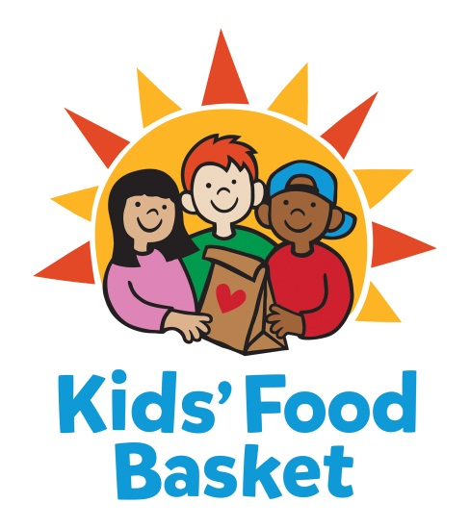

JOB POSTING

Job Title: Vice President of Programming – Expert in Residence
Reports to: Chief Operating Officer
Date: October 15, 2019

Kids’ Food Basket believes all children have a right to equitable, consistent access to the nutrition they need to grow. We got our start 17 years ago by serving 125 kids each school day through our Sack Supper program, and now we serve nearly 8,800 kids each school/summer program day throughout Kent, Muskegon and Ottawa + Allegan counties. Nourishing healthier generations of children is at the core of Kids’ Food Basket’s mission and is what we strive for daily through our four Commitments:

We Nourish our future by providing ready to eat healthy food on a daily basis to children in need,

We Grow by increasing healthy food access for our communities through the growth and distribution of sustainably grown vegetables and fruit,

Our community Learns through the use of our facilities and farm as classrooms to foster learning and empowerment across economic barriers,

We Engage our diverse community to work for Good Food for all.

If you are passionate about nourishing children to reach their dreams, then consider joining our team!

Vice President of Programming – Expert in Residence:
This three year position will have overall strategic and operational responsibility for all program areas. The position will be a part of the senior leadership team that drives the overall strategy for the organization and represents Kids’ Food Basket on a local, regional, and national basis. With a program budget of $3.6 million and a program staff of 21. The VP of Programming will initially develop deep knowledge of each project, program operations, and business plan, and will focus on the following five areas: program leadership and vision, new initiatives, external strategic relationships, funding and evaluation, and knowledge management.

RESPONSIBILITIES
Program Vision and Leadership
- Research and Develop programming framework and scalability based upon proven track record of success and future growth opportunities
- Assist with the development of annual organization and program goals and objectives that align with and support the strategic plan.
- Lead, manage and hold accountable all program team members by charting an annual course of direction and managing quarterly progress toward annual goals.
- Oversight of $3.6 million program budget, with expected growth
- Attract, develop, coach and retain high-performing team members
- Provide leadership in development of inter-team communication and cohesiveness, sustaining culture and supporting staff during organizational growth
- Creative problem solving
- Serve as organizational representative attending key meetings and venues at the local, county and state level.

New Initiatives
- Special focus on building out cohesive programming around the organization’s commitment to “GROW” – providing access to sustainably-grown fruits and vegetables for our children and families living at or near the poverty line
- Develop strategy to respond to external stakeholders and participants in the Community Food Survey, based upon gleaned results and key partner opportunities
External Partnerships
- Develop and maintain relationships with current and potential community and regional partners and other stake holders.
- Cultivate existing relationships and develop new strategic partnerships to meet the goals of the strategic growth map
- Develop revenue generating strategic partnerships
Funding and Evaluation Oversight:
- Expand revenue generating activities to support existing programs
- In partnership with Director of Development, lead the process to identify, evaluate and develop responses to funding opportunities, assuming responsibility for assuring applications are relevant and outcomes achievable.
- Ensure ongoing program excellence through evaluation
- Ensure consistent compliance with the performance expectations of all grants and contacts, including qualitative and quantitative outcomes.
- Implement and sustain an effective record keeping and data collection system for monitoring due dates, gauging staff productivity and producing outcomes and analysis reports.

Knowledge Management:
- Develop the necessary systems, processes and tools to better support the facilitation, collection and sharing of knowledge that is generated by all programs.
- Ensure that key project outcomes and/or policy, advocacy, and legislation are evaluated and leveraged for maximum community and organizational impact.
Other Duties Assigned
- Act as a spokesperson of Kids’ Food Basket at speaking engagements.
- Other duties that assist the KFB team as assigned.

General

- Participate in and assist with daily tasks of Kids’ Food Basket.
- At least 40 hours per week - flexible scheduling, typically 9am to 5pm Monday through Friday, however there are occasional evenings and weekends.
- Regular travel to Kids’ Food Basket regional locations.
- Opportunity exists for professional advancement based on work performance and organizational need

Skills and Qualifications

- 7-10 years of program development experience required
- Master’s degree or relevant experience preferred
- Experience working in the nonprofit sector as a volunteer or staff member.
- Must be able to effectively interact with a diverse population from a variety of ethnic and socioeconomic backgrounds.
- Experience speaking in front of groups, making presentations and leading group from 5-300 consisting of all ages and backgrounds.
- Be organized with the ability to work in a fast paced, ever changing work environment.
- Possesses skills in project and time management.
- Be well versed in computer programs (Microsoft Office required)
- Experience with Raisers Edge is a plus.
- Can work independently as well as collaboratively.
- Demonstrate the ability to solve problems, analyze systems and data, and make suggestions for improvement.
- Physical requirements include a typical office environment with periods of sitting at a computer screen and being able to lift up to 25 lbs.
- The job entails duties off-site including local travel.
- An understanding of fund development, stewardship and community outreach.
- Have a basic understanding of hunger and poverty issues in Grand Rapids.

Compensation: Commensurate with experience.

Benefits: Kids’ Food Basket offers a very comprehensive benefit package.

To be considered for the position, applicants must send cover letter, resume and salary requirements
via email as soon as possible.

Applications will be reviewed as they are received
(No phone calls please)

Send cover letter, resume and salary requirements to:

hiring@kidsfoodbasket.org

Kids’ Food Basket is an equal opportunity employer. Our policy provides equal employment opportunities (EEO) to all employees and applicants for employment without regard to race, creed, ethnicity, gender/gender identity, sexual orientation, religious belief, sex, national origin, age, ancestry, qualifying disability, height, weight, marital status, veteran status or genetics. In addition to federal law requirements, Kids’ Food Basket complies with applicable state and local laws governing nondiscrimination in employment in every location in which the organization has facilities.

