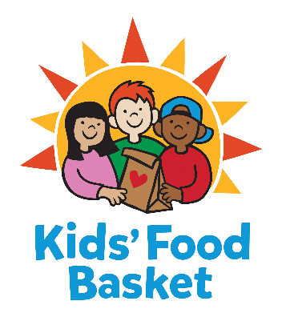

Job Title: Development and Events Intern
Reports to: Delaney Faught, Development and Events Coordinator

Summary
Kids’ Food Basket is a grassroots, community solution to childhood hunger. We engage all who care about children reaching their full potential – in school and in life. We are seeking a Development and Events Intern to support the planning and execution of events benefitting Kids’ Food Basket, communicate with community supporters, and support other fundraising tasks.

Internship Duties:
• Signature Events | Support signature events during the semester including but not limited to event logistics, sponsorship, individual ticket sales and auction support, invoicing and donor stewardship
• Connect Events | Assist with annual Connect with Kids’ Food Basket events including coordination of guest RSVP, food and donor packets
• Expansion Campaign Events | Assist with event logistics for our Feeding Our Future Ottawa & Allegan expansion campaign events including coordination of guest RSVP, food, donor packets and additional as assigned
• Community/Outreach Events | Assist Kids’ Food Basket team with activities at Kids’ Food Basket events in the community
• Third Party Fundraisers | Provide coordination and support for third party events including information, scheduling, and Kids’ Food Basket representation at events as needed
• Peer to Peer Fundraising Events | Support Kids’ Food Basket team with support of Peer to Peer Fundraising Events including assistance of prospecting events and donors, assist with stewardship and promotion of Peer to Peer Fundraising platform
• Additional administrative support | Support Kids’ Food Basket team with administrative duties including but not limited to answering phones, meeting prep and donor stewardship, donor and volunteer data entry
• Misc. duties as assigned

Requirements for Development Events and Kids Helping Kids Intern - Paid
- Bachelor degree in progress or recently completed
- Can work independently as well as collaboratively.
- Desire to learn about the work that goes into nonprofit event planning and coordination
- Some evening and weekend availability with provided notice
- Have reliable transportation to and from Kids’ Food Basket.
- Eager to learn about how a nonprofit operates.

Skills and Qualifications
- Excellent communication skills, both verbal and written
- Demonstrated poise, tact and diplomacy
- Passion for taking care of stakeholders’ needs
- Ability to train on multiple tasks and understand the larger scope of each task
- Friendly and professional demeanor
- Excellent attention to detail
- Excellent interpersonal skills both in person and over the phone with high level of professionalism
- Comfortable working with diverse populations
- Highly organized with the ability to work in a fast paced, ever changing work environment
- Possess project and time management skills
- Well versed in computer programs (Microsoft Office, Excel and Outlook preferred)
- Can work independently as well as collaboratively
- Basic understanding of hunger and poverty issues in West Michigan
Physical Activities
- Stooping. Bending body downward and forward by bending spine at the waist. This factor is important if it occurs to a considerable degree and requires full motion of the lower extremities and back muscles.
- Kneeling. Bending legs at knee to come to a rest on knee or knees.
- Reaching. Extending hand(s) and arm(s) in any direction.
- Standing. Particularly for sustained periods of time.
- Walking. Moving about on foot to accomplish tasks, particularly for long distances or moving from one work site to another.
- Lifting. Raising objects from a lower to a higher position or moving objects horizontally from position-to- position. This factor is important if it occurs to a considerable degree and requires substantial use of upper extremities and back muscles.
- Grasping. Applying pressure to an object with the fingers and palm.
- Talking. Expressing or exchanging ideas by means of the spoken word. Those activities in which one must convey detailed or important spoken instructions to other workers accurately, loudly, or quickly.
- Hearing. Perceiving the nature of sounds at normal speaking levels with or without correction. Ability to receive detailed information through oral communication, and to make the discriminations in sound.
- Environmental conditions. None. The worker is not substantially exposed to adverse environmental conditions (such as in typical office or administrative work)
Tier 1 Internship
- $599 Stipend or School Credit
- Typically 150 hours required
- If school credit is desired, it is the responsibility of the student to seek and get approval from their school.

Work Schedule
15 – 20 hours a week
January 2020 – May 1 2020
How to Apply:
Send cover letter and resume to: hiring@kidsfoodbasket.org
Kids’ Food Basket provides equal employment opportunities (EEO) to all employees and applicants for employment without regard to race, color, religion, gender, sexual orientation, gender identity or expression, national origin, age, marital status, height, weight, genetic information, qualified disability, or veteran status. In addition to federal law requirements, Kids’ Food Basket complies with applicable state and local laws governing nondiscrimination in employment in every location in which the organization has facilities.

